**Experiment No. 05**

**Object:** Introduction to VLANs.

1. To create VLANs in Switch using CLI mode.
2. To assign Ip Address to VLANs in Switch using CLI mode.
3. To assign ports of switch to VLANs of Switch using CLI mode. (single or range)

**Date:** March 03, 2018

# Configuration Figure:

# 

# Coding:

Switch>en

Switch#conf t

Enter configuration commands, one per line. End with CNTL/Z.

Switch(config)#vlan 2

Switch(config-vlan)#name admin

Switch(config-vlan)#ex

Switch(config)#vlan 3

Switch(config-vlan)#name it

Switch(config-vlan)#ex

Switch(config)#vlan 4

Switch(config-vlan)#name acc

Switch(config-vlan)#ex

Switch(config)#ex

Switch#

%SYS-5-CONFIG_I: Configured from console by console

Switch#

Switch#

Switch#

Switch#conf t

Enter configuration commands, one per line. End with CNTL/Z.

Switch(config)#interface range fastEthernet 0/1-2

Switch(config-if-range)#switchport mode access

Switch(config-if-range)#switchport access vlan 2

Switch(config-if-range)#no shutdown

Switch(config-if-range)#ex

Switch(config)#

Switch(config)#interface range fastEthernet 0/3-4

Switch(config-if-range)#switchport mode access

Switch(config-if-range)#switchport access vlan 3

Switch(config-if-range)#no shutdown

Switch(config-if-range)#ex

Switch(config)#

Switch(config)#interface fastEthernet 0/5

Switch(config-if)#switchport mode access

Switch(config-if)#switchport access vlan 4

Switch(config-if)#no shutdown

Switch(config-if)#ex

Switch(config)#

Switch(config)#ex

Switch#

%SYS-5-CONFIG_I: Configured from console by console

Switch#show vlan

VLAN Name Status Ports

---- -------------------------------- --------- -------------------------------

1 default active Fa0/6, Fa0/7, Fa0/8, Fa0/9

Fa0/10, Fa0/11, Fa0/12, Fa0/13

Fa0/14, Fa0/15, Fa0/16, Fa0/17

Fa0/18, Fa0/19, Fa0/20, Fa0/21

Fa0/22, Fa0/23, Fa0/24, Gig0/1

Gig0/2

2 admin active Fa0/1, Fa0/2

3 it active Fa0/3, Fa0/4

4 acc active Fa0/5

1002 fddi-default act/unsup

1003 token-ring-default act/unsup

1004 fddinet-default act/unsup

1005 trnet-default act/unsup

VLAN Type SAID MTU Parent RingNo BridgeNo Stp BrdgMode Trans1 Trans2

---- ----- ---------- ----- ------ ------ -------- ---- -------- ------ ------

1 enet 100001 1500 - - - - - 0 0

2 enet 100002 1500 - - - - - 0 0

3 enet 100003 1500 - - - - - 0 0

4 enet 100004 1500 - - - - - 0 0

1002 fddi 101002 1500 - - - - - 0 0

1003 tr 101003 1500 - - - - - 0 0

1004 fdnet 101004 1500 - - - ieee - 0 0

1005 trnet 101005 1500 - - - ibm - 0 0

Remote SPAN VLANs

------------------------------------------------------------------------------

Primary Secondary Type Ports

------- --------- ----------------- ------------------------------------------

Switch#

Switch#conf t

Enter configuration commands, one per line. End with CNTL/Z.

Switch(config)#interface vlan 2

Switch(config-if)#

%LINK-5-CHANGED: Interface Vlan2, changed state to up

%LINEPROTO-5-UPDOWN: Line protocol on Interface Vlan2, changed state to up

Switch(config-if)#ip address 192.168.0.6 255.255.255.0

Switch(config-if)#no shutdown

Switch(config-if)#ex

Switch(config)#interface vlan 3

Switch(config-if)#

%LINK-5-CHANGED: Interface Vlan3, changed state to up

%LINEPROTO-5-UPDOWN: Line protocol on Interface Vlan3, changed state to up

Switch(config-if)#ip address 192.168.0.7 255.255.255.0

Switch(config-if)#no shutdown

Switch(config-if)#ex

Switch(config)#interface vlan 4

Switch(config-if)#

%LINK-5-CHANGED: Interface Vlan4, changed state to up

%LINEPROTO-5-UPDOWN: Line protocol on Interface Vlan4, changed state to up

Switch(config-if)#ip address 192.168.0.8 255.255.255.0

Switch(config-if)#no shutdown

Switch(config-if)#ex

Switch(config)#

Switch(config)#ex

Switch#

%SYS-5-CONFIG_I: Configured from console by console

Switch#

Switch#conf t

Enter configuration commands, one per line. End with CNTL/Z.

Switch(config)#interface vlan 1

Switch(config-if)#ip address 192.168.0.5 255.255.255.0

Switch(config-if)#no shutdown

Switch(config-if)#

%LINK-5-CHANGED: Interface Vlan1, changed state to up

%LINEPROTO-5-UPDOWN: Line protocol on Interface Vlan1, changed state to up

Switch(config-if)#ex

Switch(config)#ex

Switch#ex

Switch>

Switch con0 is now available

Press RETURN to get started.

Switch>

# Command Prompt Result:

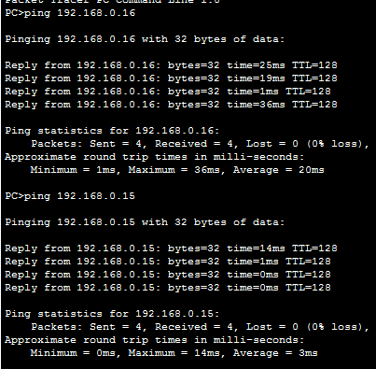

VLAN 1

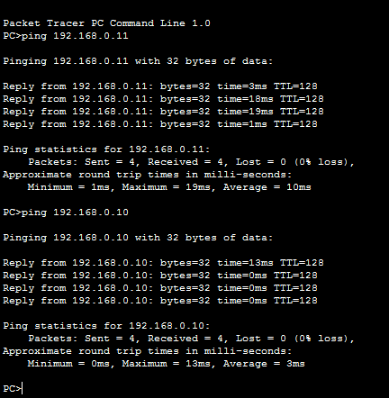

VLAN 2

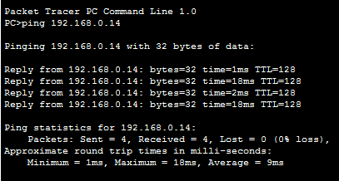

VLAN 4

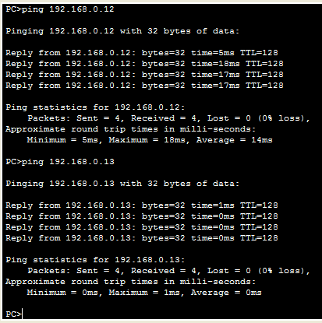

VLAN 3